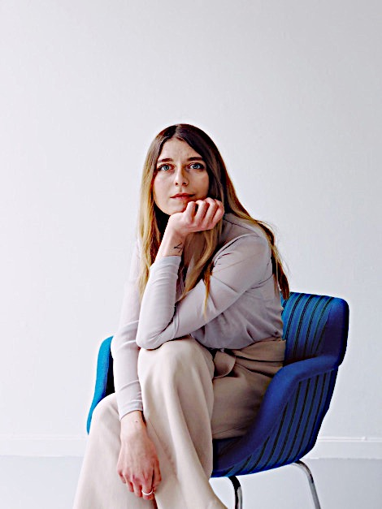
Mariia Drachuk
Bio:
Mariia Drachuk
08.06.1993, Kyiv, Ukraine
Based: Trondheim, Norway
Phone: +4796710170
Mail: ​mariiadrachuk@gmail.com
Website: mariiadrachuk.com
Current:
Norske Billedkunstnere member
Board member of Husrådet, LKV
Education:
Master in fine arts
Academy in Trondheim, KiT,
NTNU 1.09.2016 – 06.06. 2018, Trondheim, Norway
Bachelor in Cultural Studies
Kyiv-Mohyla Academy
1.09.2010 – 20.08.2014, Kiev, Ukraine
Other educational programs:
Modern Art Research Institute
15.12.2015 – 4.08.2016, Kiev, Ukraine
School of Visual Communications
01.12.2015 – 20.01.2016, Kiev, Ukraine
Gallery experience
Babel Visningsrom for Kunst, Trondheim, Norway
gallery guard - 15. 06. 2019 - currently working here
Galleri Blunk, Trondheim, Norway
former board member September 2017- January 2018
Art platform “IZONE”, Kiev, Ukraine - Receptionist.
Welcoming visitors, answering and referring inquiries, financial reporting, accounting preparation, supplies and purveyance control, mediation between workshops and management, events and store management, phone calls, email correspondence - August 2015 - October 2015
Pinchuk Art Centre, Kiev, Ukraine - Mediator. Mediation between visitors and exhibition - assistant duties and help providing during all of the events in the art centre -Greeting visitors - January 2014 – July 2014 - http://pinchukartcentre.org/en/
Collaborations
“Untitled”, with Gard Aukrust, Trondheim, Norway 2018 “Free Therapy session”, with Gard Aukrust, Trondheim, Norway 2016 “Soft Spaces”, with Hanna Legun, Kiev, Ukraine 2015
Exhibitions
Solo, ​Between Matters Inside and Outside, ​2019, Babel Visningsrom for Kunst, Trondheim, Norway
Group, ​Unge Inviterte, 2​ 019, LNM, Oslo, Norway
Group, ​GAS, ​2018, Gråmølna, Trondheim Kunstmuseum - Trondheim, Norway Solo, ​Dust​, 2018, Galleri Blunk- Trondheim, Norway
Group, ​Book Happening,​ 2018 Galleri KiT - Trondheim, Norway
Group, ​Invisible Spaces​, 2017, Kunstarken, Underfladen - Trondheim, Norway Group, ​Performance Night​, 2017, Galleri KiT - Trondheim, Norway
Group, ​Open Academy​, 2016, Galleri KiT - Trondheim, Norway
Group, ​Optique,​ 2015, Modern Art Research Institute - Kiev, Ukraine Publications and interview
Babel Visningsrom for Kunst, interview with Ane Ulrikke Bak, 2019,
https://babelkunst.no/2019/06/06/mariia-drachuk-between-matters-insid e-and-outside/
Subjekt.no, 20.06.2019,
https://subjekt.no/2019/06/20/det-beste-pa-trondheims-kunstscene-akku rat-na/
Klassekampen, cover-back, “Perspektiv”, 3.06.2019 Subjekt.no, 10.01.2019,
https://subjekt.no/2019/01/10/oslos-beste-utstillinger-akkurat-na/
Billedkunst No. 3, Familien, 2018 List, Summer, 2018

